
IIR Project

Introduction
You have just joined a “start up” company as the resident DSP expert. Your company has just decided to get into the remote distributed sensor (intelligent dust) business. The in-field sensors need communicate detected events to some central location and, it is claimed, that these events are binary valued (YES/NO). The firm’s engineers consider running wires and cables to the sensors logistically unacceptable. An RF and/or optical link, it is felt, is too insecure and can disclose the sensors position. The conjecture that over short distances, audio-acoustic signaling may be possible (yes, I know that it has the same problem as the RF and optical links, its an academic problem, OK?).
The sensors, upon detecting an event are programmed to broadcast a tone at f kHz. You are charged with designing, testing, and implementing a narrowband digital audio-acoustic filter that can detect the presence of the broadcast tone. You are told to use a sample rate of 44.1K Sa/s and to expect the transmitted monotone signal to be possibly contaminated by complex acoustical background noise from the local environment (e.g., broadband acoustical chaos). The system that you are to develop is to detect the presence of the narrowband tone at a frequency f kHz from the received signal. This requires that you design a bandpass IIR having a center frequency f and meets the following presented in Table 1. Your design is also to have a maximum passband error deviation of -1.5dB and the maximum stopband error of -40dB.

Table 1: Frequency assignment (frequencies in kHz).
Item\Group | G1 | G2 | G3 | G4 | G5 | G6 | G7 | G8
F (center) | 2.5 | 3 | 3.5 | 4 | 4.5 | 5 | 5.5 | 6
Passband | f±0.2 | f±0.2 | f±0.2 | f±0.2 | f±0.2 | f±0.2 | f±0.2 | f±0.2
Lower stopband | f-0.5 | f-0.5 | f-0.5 | f-0.5 | f-0.5 | f-0.5 | f-0.5 | f-0.5
Upper stopband | f+0.5 | f+0.5 | f+0.5 | f+0.5 | f+0.5 | f+0.5 | f+0.5 | f+0.5
Sample rate | 44.1 | 44.1 | 44.1 | 44.1 | 44.1 | 44.1 | 44.1 | 44.1

Part 1: IIR Design
  - Using MATLAB, design candidate tone detection filters using a Butterworth, Chebyshev I, Chebyshev II, Elliptic digital IIR models and the bilinear-z transform. Determine the minimum filter order(s) needed to meet or exceed the given specifications. Summarize your design after Table 2.
Table 2: Filter Design Comparison
Filter | Order | Max. passband error (dB) | Max. lower stopband error (dB) | Max. upper stopband error (dB)
Butterworth
Chebyshev I
Chebyshev II
Elliptic

Plot the IIR’s pole-zero distribution on a common set of axis and compare (see Figure 1).
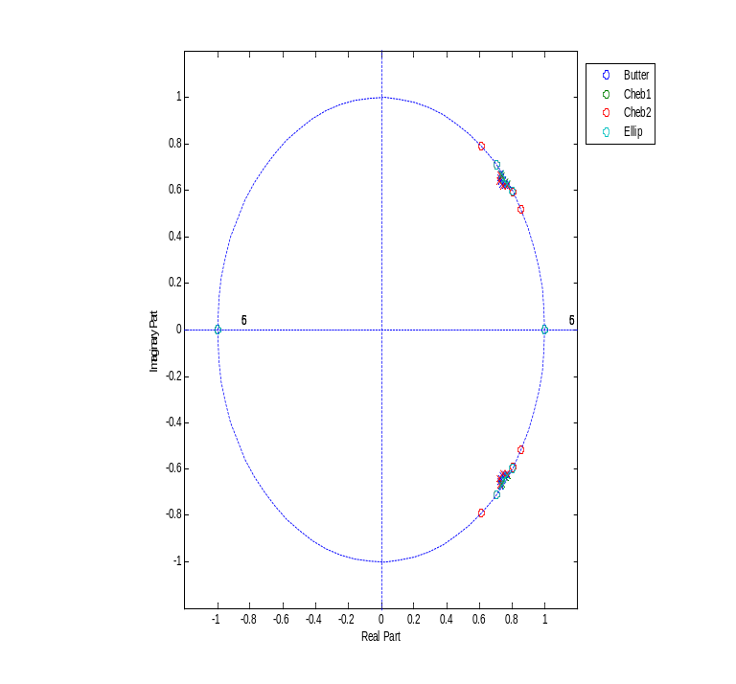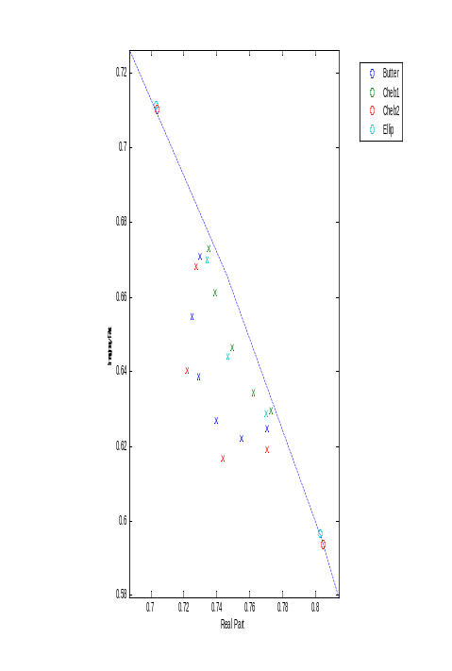
Fig.1. Illustrative zero-pole plots for all the IIR filters (left) and zoom veiw (right).
1.2 Choose an elliptic IIR for continued study. If the minimum order of the elliptic designed in Part 1.1 exceeds order N=6, then use (re-design) a 6th order elliptic IIR that best meets the specification (i.e., relax the stopband attenuation). Display the 6th order filter’s transfer function, magnitude frequency response (linear and dB), and group delay.
1.3: You are motivated to design a pre-emphasized IIR having a slightly increasing the gain in the upper range of the passband relative to the lower range of the passband by 15%. Achieve this design goal by manipulating the poles and/or zeros of your 6th order filter (see Figure 2 for an example of increasing the lower range of the passband by 15%).
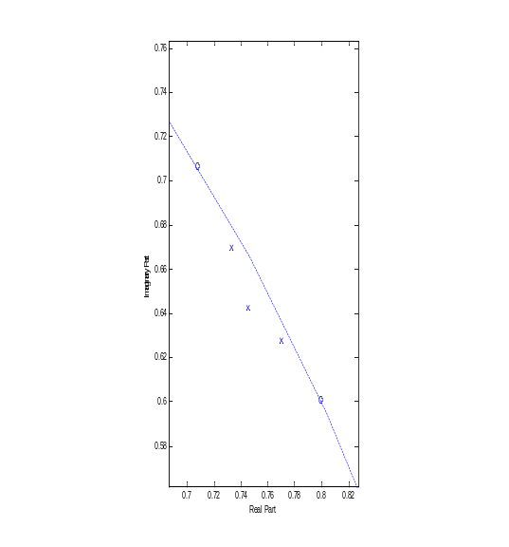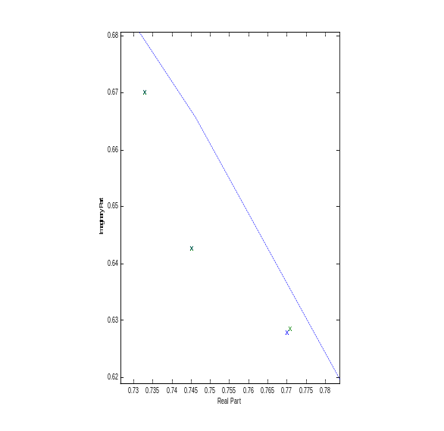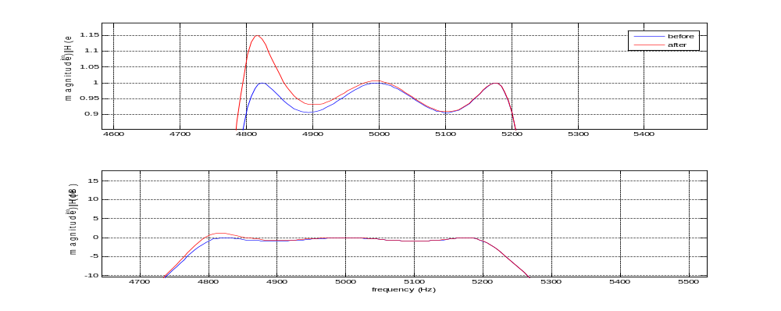
Fig.2. (a) Zoom expansion of the Elliptic filter poles an zeros; (b) pole relocation (green); and (c) the frequency magnitude response comparison before and after pole relocation.
1.4 Using MATLAB and the 6th order IIR from Part 1.2, simulate the filter’s performance in the presence of a tone and broadband noise. The broadband audio process is to be modeled as a long zero mean Gaussian random time. Adjust the background noise to have SNR = {∞, 10, 0, -10}, compute and display the input and output power spectral densities (overlay). What is the SNR measured at the filter’s output? Does the outcome agree with your intuitive and mathematical understanding on how the filter should work?
A simple example of power spectrum analysis, shown below, was conducted using MATLAB’s pmtm function. You may or may not want to go down this path. You can use any technique that is mathematically consistent with the studies goals.

>> Fs=1000; t=0:1/Fs:.5;
>> x=cos(2*pi*t*100)+randn(size(t));
>> [Pxx,Pxxc,F]=pmtm(x,4,[],Fs,'adapt');
>> plot(Pxx)

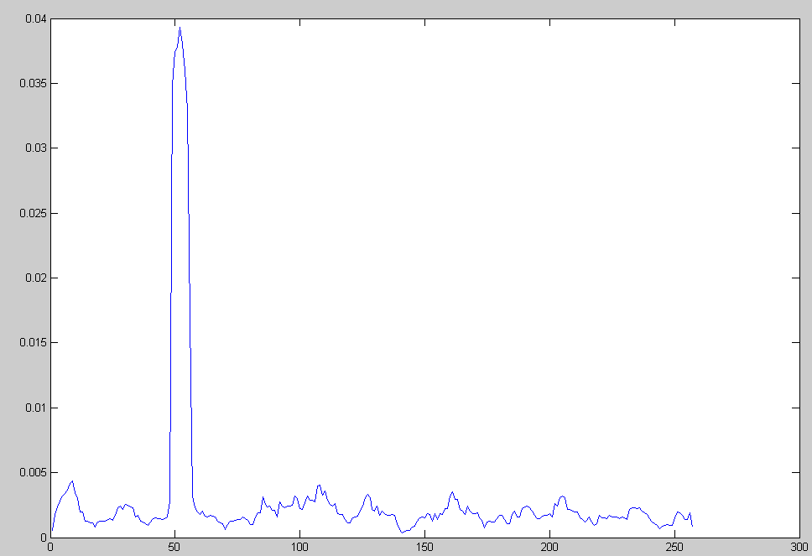
Fig.3. Power spectrum display before filtering.

Part II: IIR Architecture
2.1 Implement, using MATLAB, your elliptic IIR as a Direct II and Cascade filter using MATLAB-enabled architectures. What are the resulting 4-tuples [A,b,c,d] per architecture, along with any associated non-unity input scale factor k?
Illustration: Direct II/Cascade Solutions
Given an IIR with the transfer function H(z)=k Num(z)/Den(z), where:
scale factor = 0.0027;
num = 1.0000 -3.0136 3.2621 -0.0000 -3.2621 3.0136 -1.000;
den = 1.0000 -4.4962 9.6788 -12.1817 9.4904 -4.3228 0.9427;
the Direct II filter 4-tuple is (using normal state representation)
A = [ 0 1.0000 0 0 0 0
0 0 1.0000 0 0 0
0 0 0 1.0000 0 0
0 0 0 0 1.0000 0
0 0 0 0 0 1.0000
-0.9427 4.3228 -9.4904 12.1817 -9.6788 4.4962];
b = [0;0;0;0;0;1]; c = [-1.9427 7.3364 -12.7524 12.1817 -6.4167 1.4825]; d = 1;
For Cascade, the 2nd sections are individually:
scale factor = 0.0027; SOS = [1.0000 -0.0000 -1.0000 1.0000 -1.4902 0.9682
1.0000 -1.4151 1.0000 1.0000 -1.4660 0.9863
1.0000 -1.5986 1.0000 1.0000 -1.5400 0.9872];
For the each sos, the state 4-tuples are:
A1 = [0 1;-0.9682 1.4902]; b1 = [0;1]; c1 = [-1.9682 1.4902]; d1 = 1;
A2 = [0 1;-0.9863 1.4660]; b2 = [0;1]; c2 = [0.0137 0.0509]; d2 = 1;
A3 = [0 1;-0.9872 1.5400]; b3 = [0;1]; c3 = [0.0128 -0.0586]; d3 = 1;
  - Summarize your designs in table form (see Table 3) which lists the absolute value of the largest and smallest (non-zero) Direct II and Cascade filter coefficients or constant, and the number of non-zero, non-unity coefficients associated with each of the architectures.
Table 3: Filter Coefficients Summary
Architecture\coefficient | |Largest| | |Smallest| | #of nonzero, non-unity coefficients
Direct II
Cascade

2.3 Since the audio application requires a relatively low sample rate (44.1 kSa/s) and cost is not an issue, you consider a floating-point design. Based on your architectural analysis, which architecture would you recommend and why?

Part III: IIR Test and Evaluation
Consider again the Direct II and Cascade architectures studied in Part II.

3.1 Determine the L₂ state norm for each state and output for each architecture. .
3.2 Determine the L_{inf} frequency domain state norm for each state and output for each architecture.
3.3 Determine the L₁ state norm for each state and output for each architecture.

Table the results from Parts 3.1, 3.2, and 3.3.
Table 4: L_{p} norms
L₂ | x₁ | x₂ | x₃ | x₄ | x₅ | x₆ | y
Direct II
Cascade
L_{inf} | x₁ | x₂ | x₃ | x₄ | x₅ | x₆ | y
Direct II
Cascade
L₁ | x₁ | x₂ | x₃ | x₄ | x₅ | x₆ | y
Direct II
Cascade

  - Conduct a finite wordlength study for a signed 16-bit word architecture consisting of I integer bits and F fractional bits (I+F+1=16) for both the Direct II and Cascade architecture. Using MATLAB, design and implement a fixed-point simulator (without extended precision accumulators (i.e., M=0)), for each architecture. The simulator will need to implement fixed-point arithmetic for the production all states and outputs involving a non-unity or non-zero production rules. Add to you simulation a counter that will determine the number of system-wide accumulator overflows that occur run-time. Handle all run-time overflows using saturating arithmetic. Use floating-point to define an assumed infinite precision (ideal) response, and define the error to be the difference between the ideal and fixed-point response. Conduct a study for F ranging from 15 to 0-bits, using a common unit bound signed random noise record of length at least 1024 samples, preferably longer. Display the outcome in graphical form, plotting realized fractional precision against F (in bits) as well as the number of run-time overflows. A motivational example is shown in Figure 4.

  - Based on the outcome from Part 3.4, how does the experimental study reconcile itself with the computed L₁ norms?

  - Select the best 16-bit solution from Part 3.4. Run the four SNR signals used in Part 1.4 through your filter. Compare the input and output SNRs for the fixed-point design.

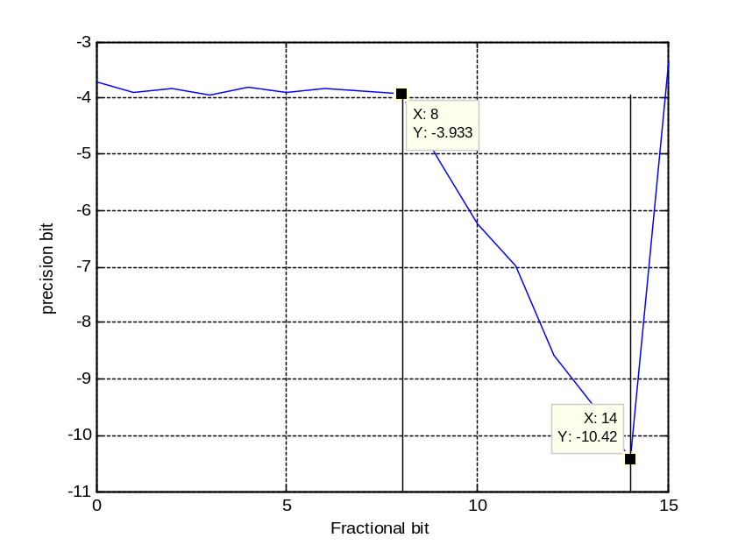Fig.4. Cascade: Output error (in bits) vs. fractional bits (add average overflow count per filter clock cycle to graph).
Add overflow count
  - For the SNR=infinty case (no noise), compare the input and output waveforms. Adjust them so the more or less coincide (either determine the required shift in samples from the graph or compute from the group delay). Determine the mean error and error variance.

Part IV: Applications
4.1 Due to the long duration of the impulse response of a narrowband IIR filter (see Figure 5), the response time of your system is considered important. In the absence of any additive background interference, how long (in samples) after the tone arrives would it take for the output to raise to 50%, 75% and 95% of its steady state value (i.e., signaling latency),
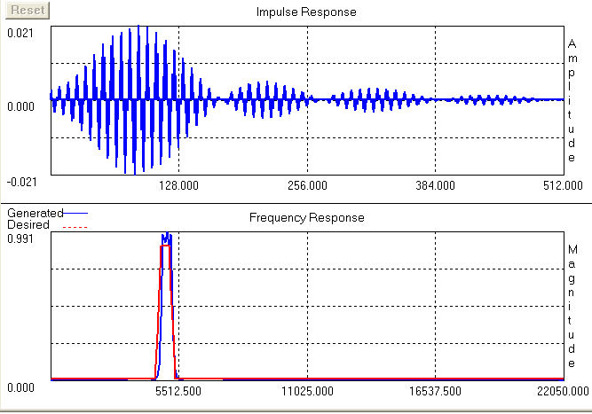
Figure 5: Impulse response (top) and narrowband magnitude frequency response (bottom).
4.2 Run-time analysis
The system shown in Figure 6 is assembled which is based on the use of a TMS320VC5510A Fixed-Point Digital Signal Processor. The DSP μp has a dual arithmetic processor which you have access to only one of the processors, the other is being used for other business.

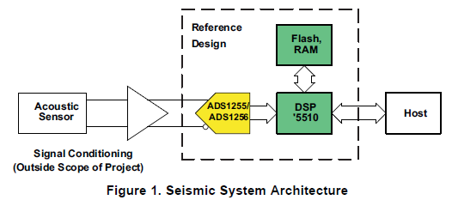
Figure 6: Sensor signal processing system (TI literature).
TMS320VC5510A Fixed-Point Digital Signal Processor Description
Features:
High-Performance, Low-Power, Dual Arithmetic Units
6.25ns Instruction Cycle Time at 160MHz Clock Rate
Dual 17-bit x17-bit multipliers coupled to 40-bit dedicated adders for non-pipelined single-cycle multiply accumulate (MAC) operations Dual Multipliers (Up to 400 Million Multiply-Accumulates Per Second (MMACS))
Hypothetical production of a 4 term inner product y=c^{T}x is suggested below. It is assumed that data shifts (i.e., FIFO management), data reads and write, overlap the arithmetic operations and add, at most, 2 additional instruction delays, and that data is read from dual ported memory..
Software Pipelining
Cycle D1 D2 MAC
1 ldh ldh 6.25ns
2 ldh ldh mac
3 ldh ldh mac
4 ldh ldh mac
5 mac
ldh=load data mac=multiply accumulate

Using this model, what is a reasonable estimate of the IIR filter cycle

4.3 Extended Precision Design
The MS320VC5510A processor follows a 17x17-bit (assumed full precision) multiplier with a 40-bit accumulator. How would this qualitatively change the fixed-point experimental study outcomes reported in Part 3.4?

REPORT
The IIR project written reports are tentatively due before class on Nov. 10, 2008. There is a 10-page limit to your report. What I want to see are your crisp responses to each part of the IIR project. As with any good report I expect to see the following items (provided as guideline):
Executive Summary (high level overview, maximum 100 words)
Statement of the Problem
Study Plan
Discussion of Results (Main body)
Summary
References/Bibliography
Project will be submitted as a hardcopy on the due date (or before). No email submissions will be accepted.

Group Assignments
Group | Last Name | First Name | User ID
1 | Adeladan | Oluwatosin | atosin
2 | Ahmad | Syed | sowaiahmad
3 | Anne | Niharika | nianne
4 | Balaga | Siva | balagasat
5 | Bibikar | Salil | sbibikar
6 | Chen | Jikai | yfgchen
7 | Chen | Qian | qiantrue
8 | Chinta | Raviteja | ravitejac
1 | Deshmukh | Rucha | rdeshmukh
2 | Dougherty | Christopher | chrisdoc
3 | Fan | Yu | daisyfan
4 | Galloza | Hector | hgalloza
5 | Garcia | Rafael | ragarcia
6 | Gosrani | Kunal | kgosrani
7 | Graves | Eric | ericsgra
7 | Guan | Xin | guanxin
1 | Gundapuneni | Rahul | rahul1984
2 | Gupta | Gunjan | gunjangupta
3 | Haile | Mulugeta | mhaile
4 | Hasanbelliu | Erion | erioni
5 | Hett | Christopher | littlema
6 | Hollensen | Christopher | cholnsn
7 | Irby | Geoffrey | geezncol
8 | Iyer | Arvind | arvindr100
1 | Iyer | Neeleshwar | niyer2
2 | Kalidindi | Kiran | kkiranvarma
3 | Karwacki | Robert | robol
4 | Keen | Sara | maxpower
5 | Kia | Behnam | behnam.kia
6 | Leng | Jiadi | lengjiadi
7 | Li | Baolong | f19850325
8 | Lughmani | Taha | tahalughmani
1 | Magapu | Raghu | raghu22
2 | Mathur | Megha | megha.mathur
3 | Mcintee | Robert | balios
4 | Meyer | Christopher | toph
5 | Misas | Orlando | omisa001
6 | Mulvaney | Brian | mulvaney
7 | Panjwani | Rishi | rrishi
8 | Parkinson | Alexander | okalex
1 | Potluri | Sindhu | cindy27
2 | Pottim | Karunakar | kpottim
3 | Ramakrishnan | Padmanabhan | padmanabhanr
4 | Rao | Yuan | yrao1
5 | Richardson | Justin | jstrds
6 | Sen | Tilottama | tiltsen
7 | Shah | Pranali | pranali.shah
8 | Sharma | Mayank | mav1984
1 | Singh | Chandni | chandni.singh
2 | Singhal | Surbhi | surbhisinghal
3 | Sishtla | Venkata | divyamadhuri
4 | Sooryanarayanan | Padma | s.padma
5 | Sun | Jingjing | sunjingjingmia
6 | Talloju | Karthik | karthik.t
7 | Thota | Aditya | aditya.thota
8 | Vardhan | Avantika | avardhan
1 | Varghese | Reno | renovar707
2 | Venkatachari | Balaji | bvk
3 | Wang | Tong | t.wang
4 | Williams | Jason | jason.d.williams
5 | Yan | Yan | swallow314
6 | Yang | Yan | kathyyang
7 | Yu | Xiaogang | xyu

